**Software Testing Assignment**

**Module–1(Fundamental)**

* **What is Software testing?**
* **Ans: Software Testing is a method to check whether the product requirement is matches with customer Requirements and make a software product that is Defect free.**
* **What is SDLC?**
* **Ans: SDLC is Software Development Life Cycle. It is the sequence of activities carried out by Developers to design and develop high-quality software**
* **What is agile methodology?**
* **Agile SDLC model is a combination of iterative and incremental process model .**

1. **What is SRS?**

* **A software requirements specification (SRS) what things we need to developed a software.**

1. **Draw Usecase on Online book shopping.**

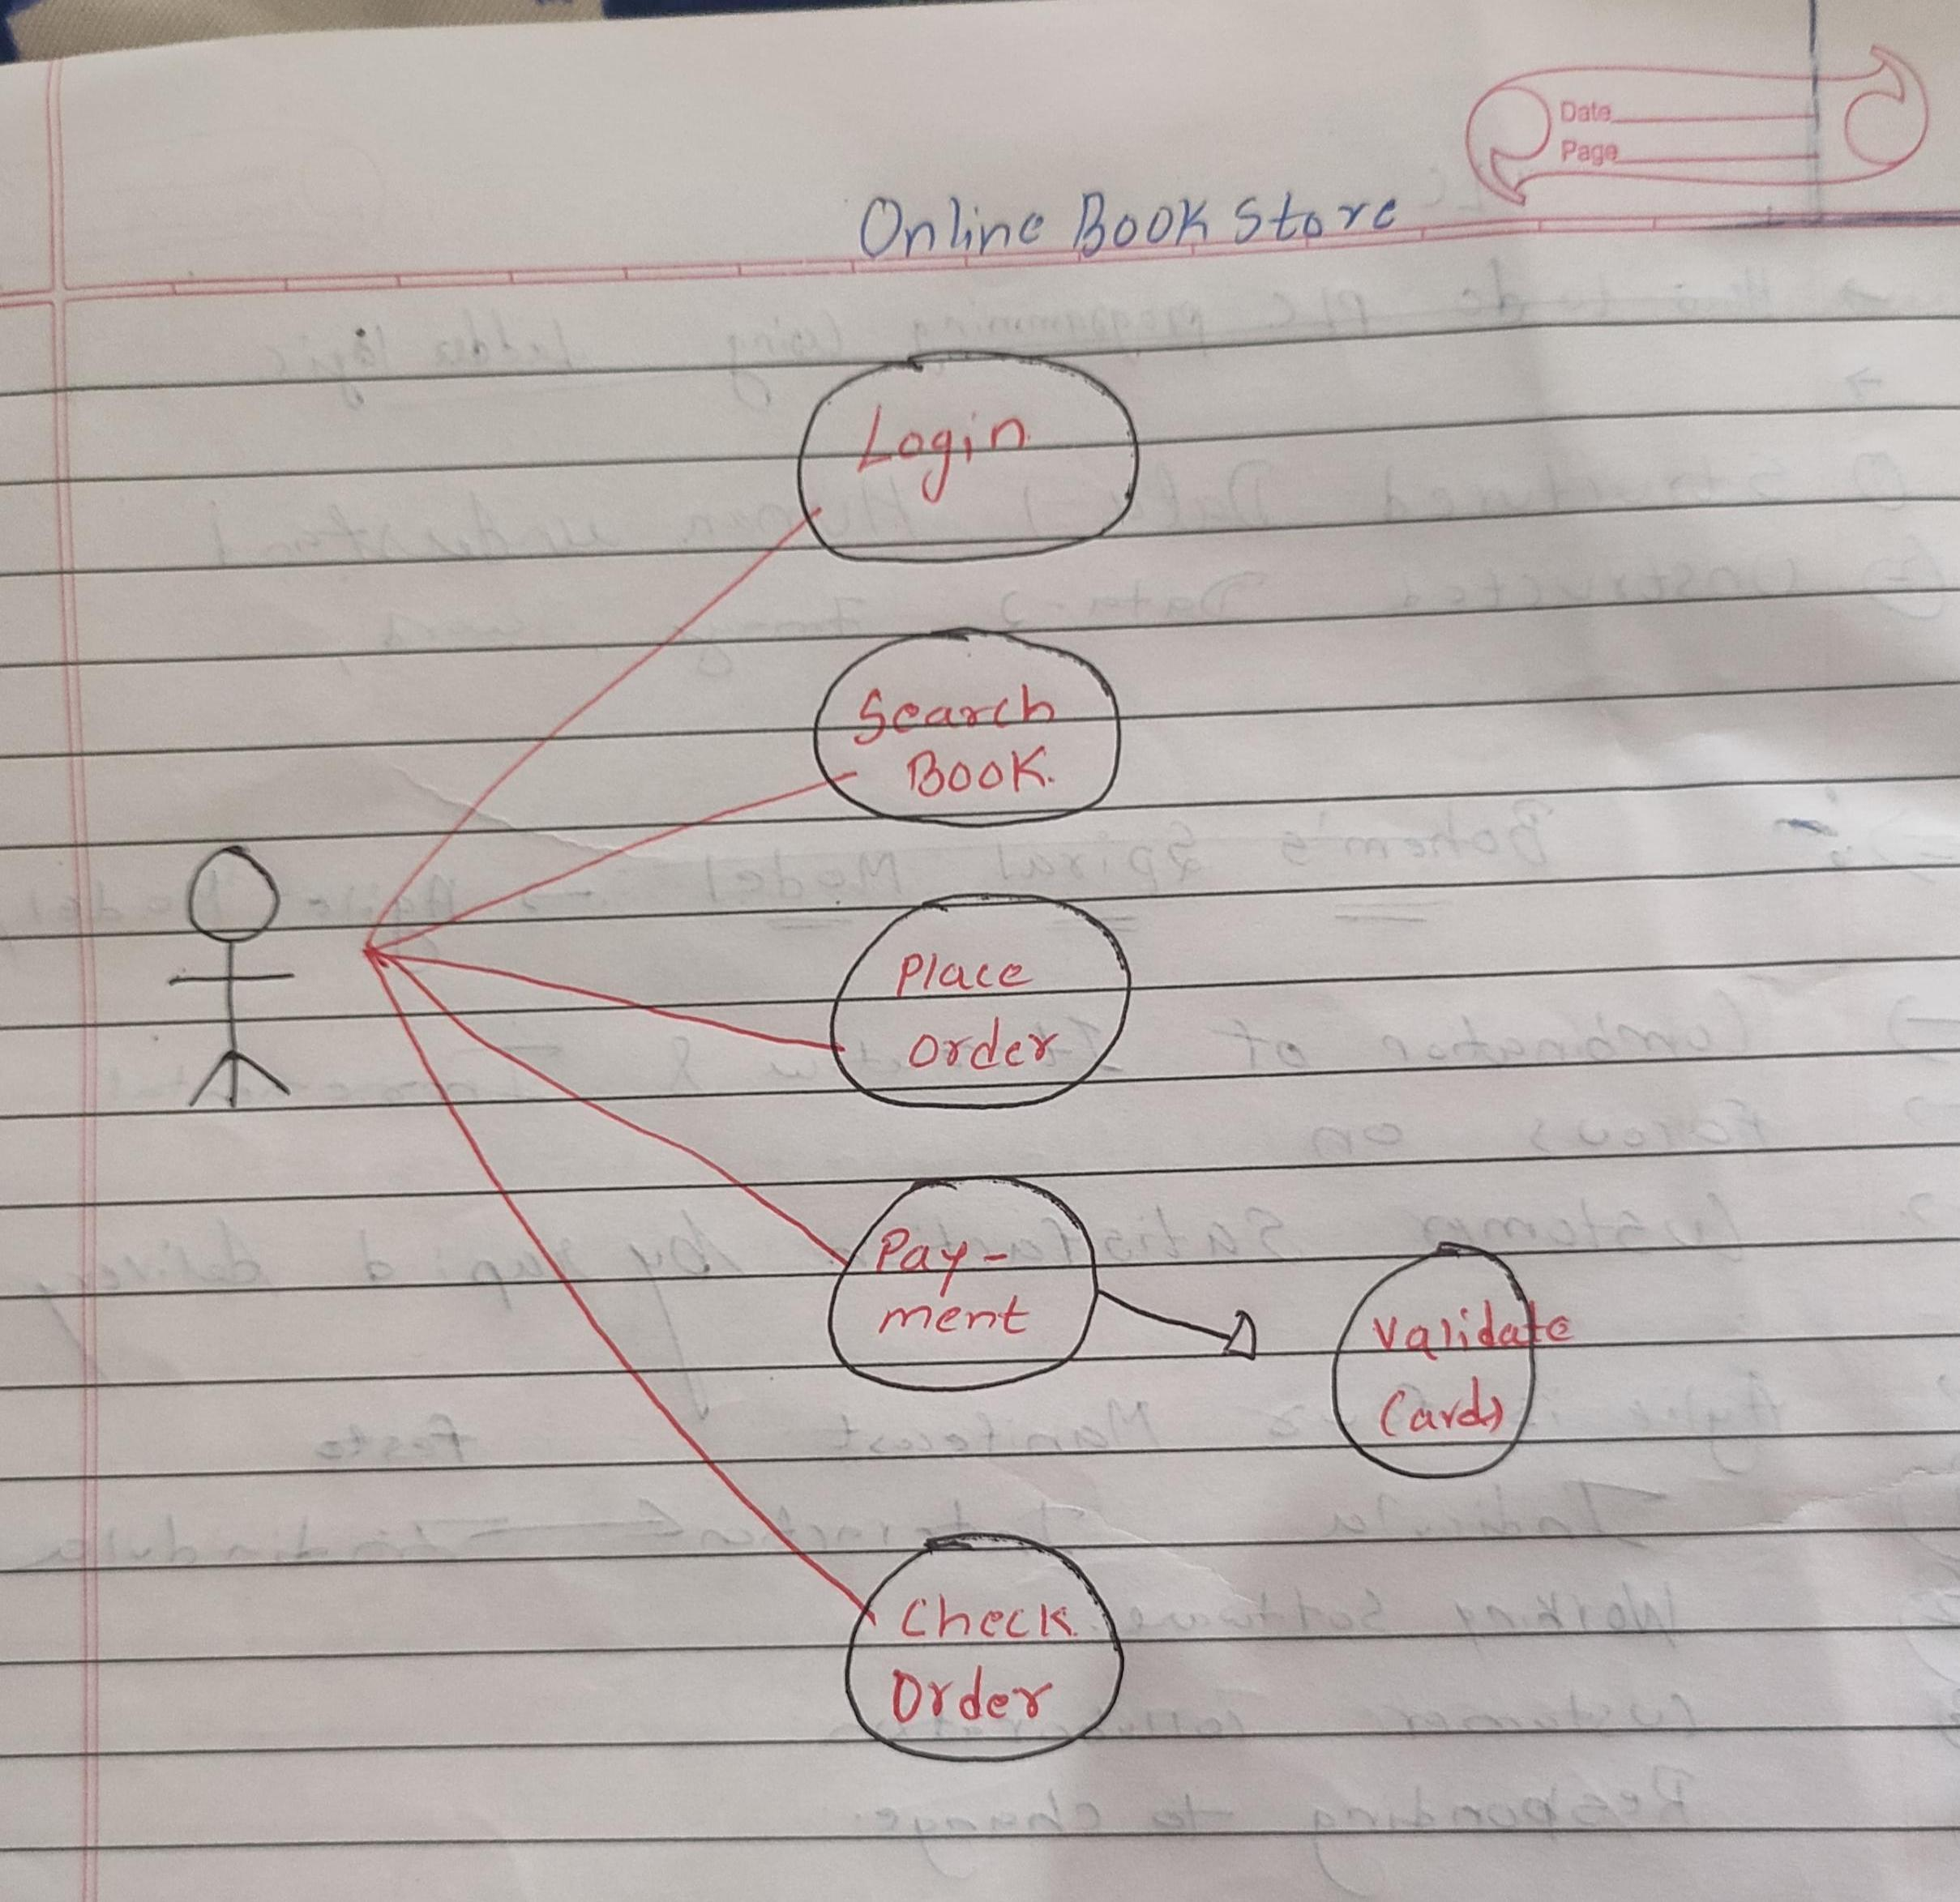

1. **Draw Usecase on online bill payment system (paytm).**

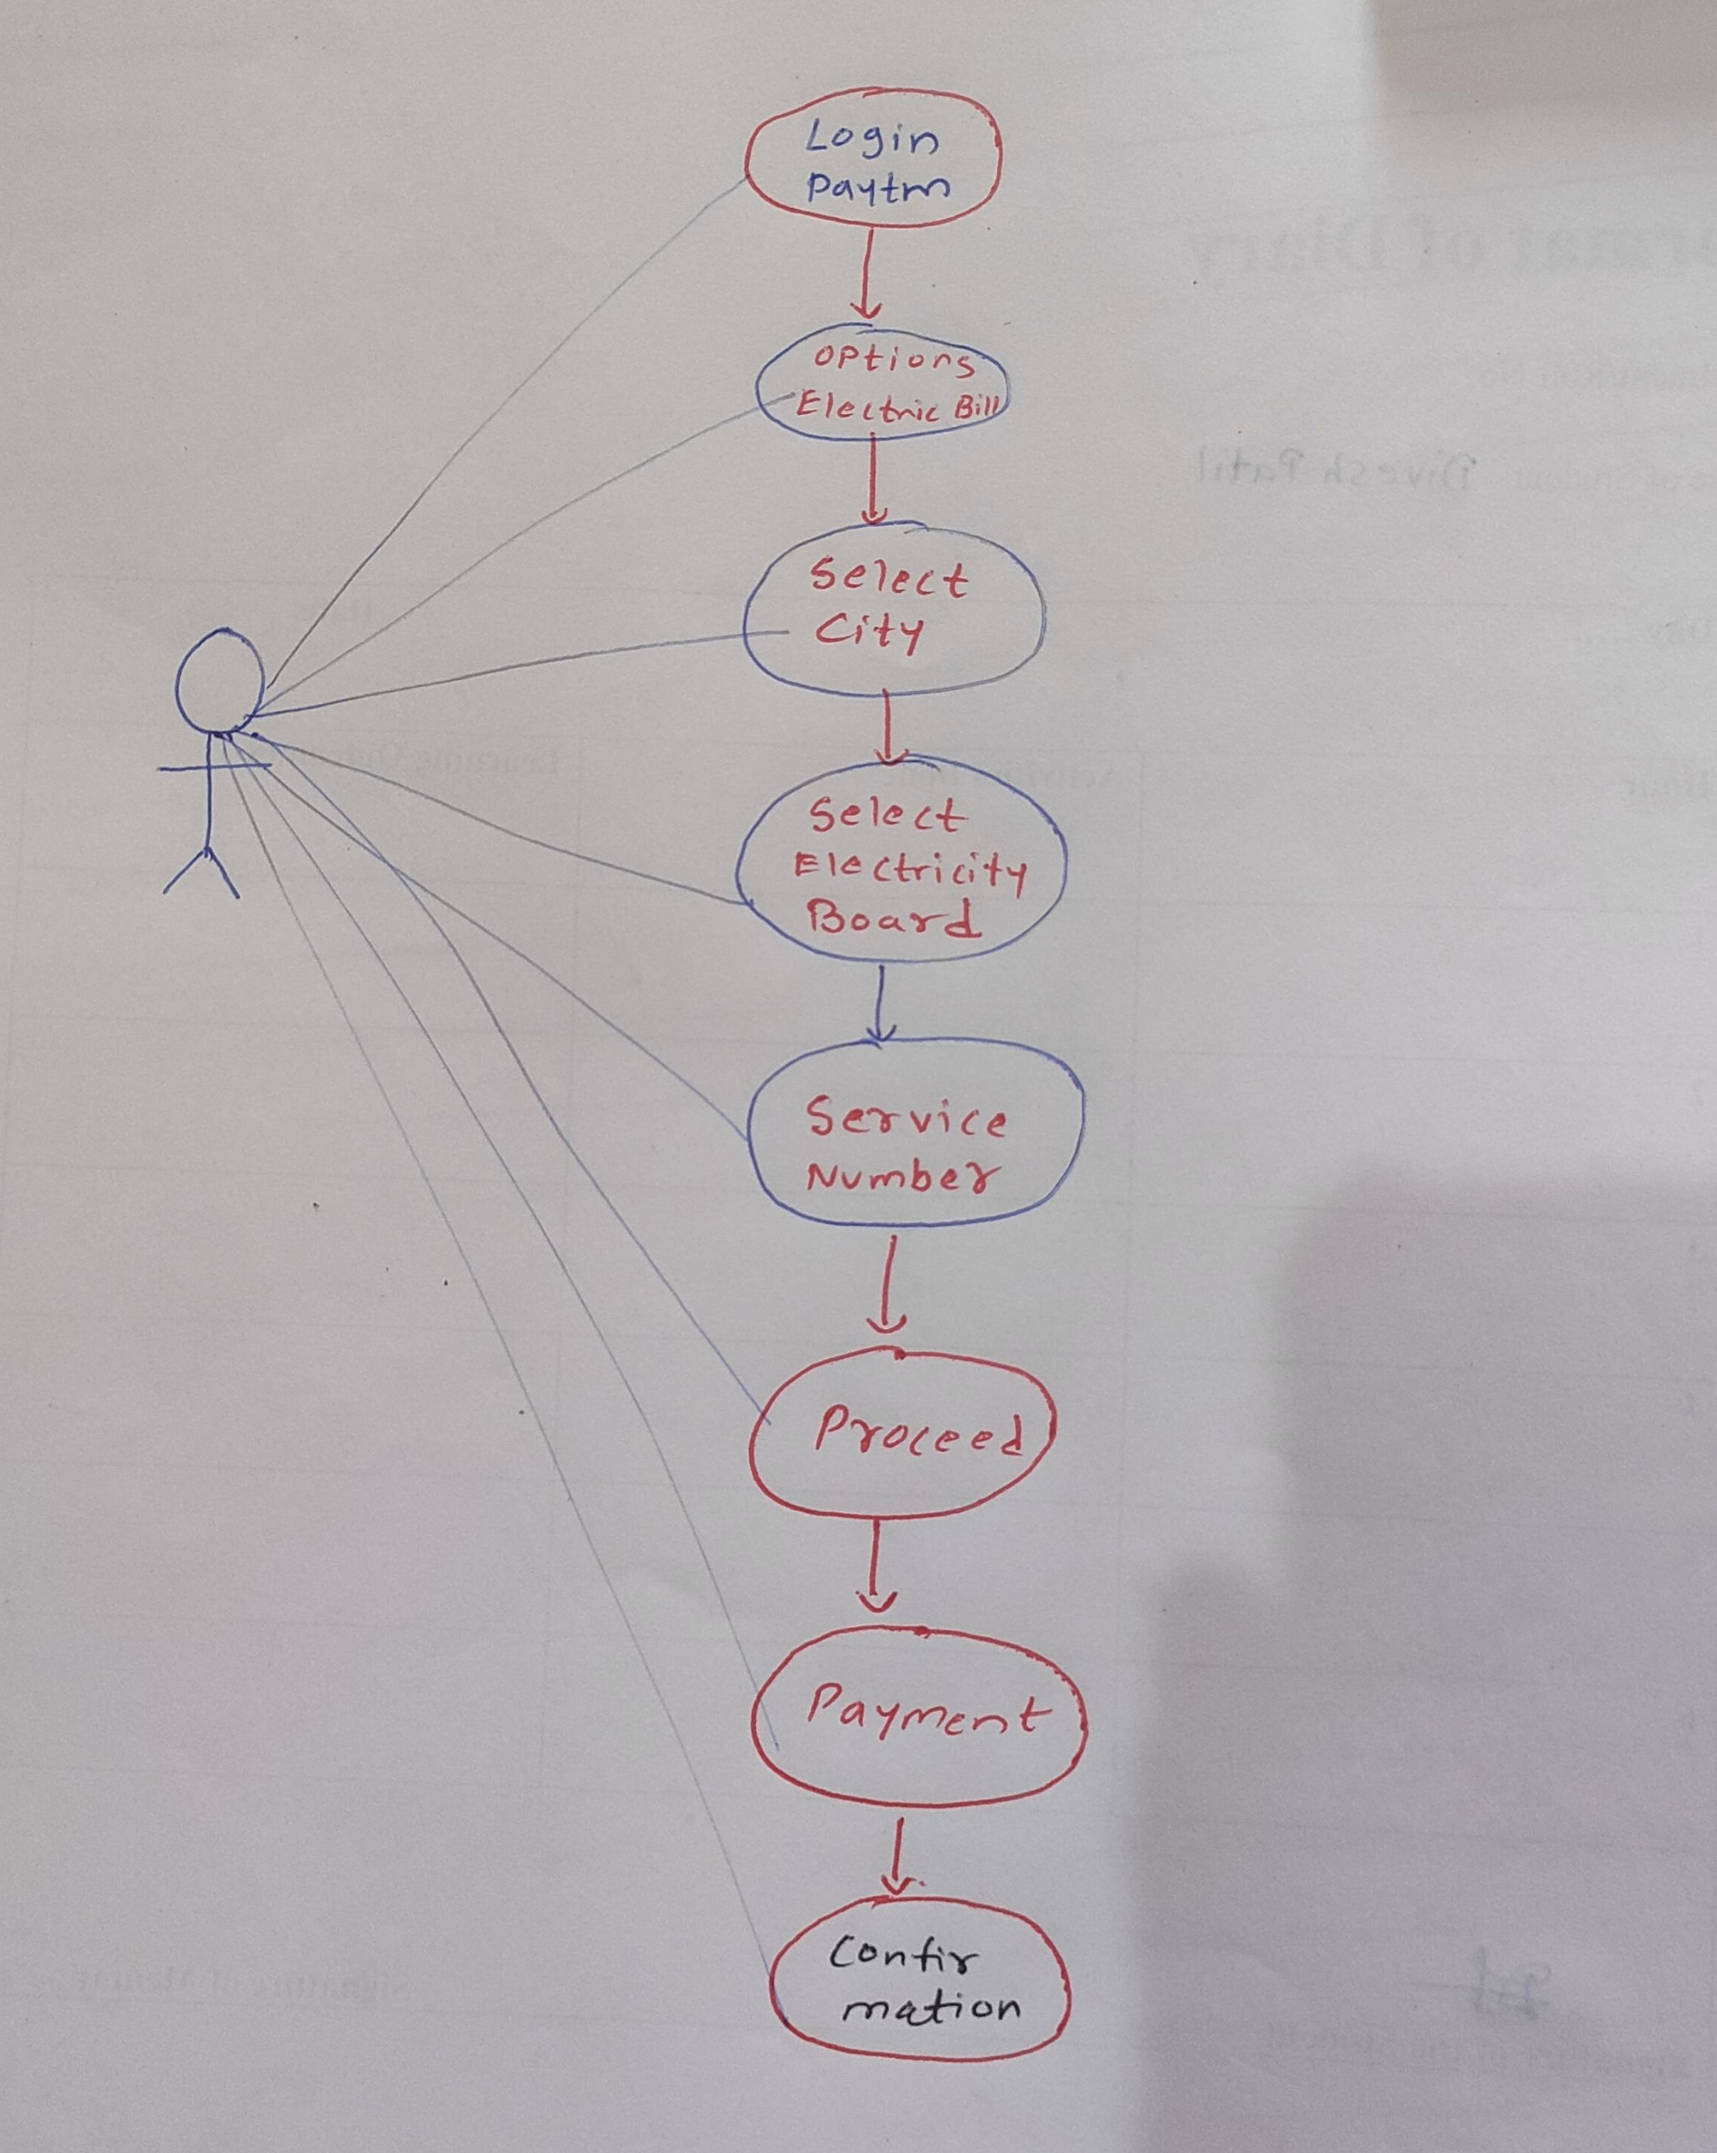

1. **Write SDLC phases with basic introduction.**

* **There are following six major phases in every Software Testing Life Cycle Model.**
* **Requirement**
* **Analysis**
* **Design**
* **Implementation**
* **Testing**
* **Maintenance**

1. **Requirment: Requirement Analysis in which test team studies the requirements from a testing point of view to identify testable requirements.**

**Three types of problems can arise:**

1. **Lack of clarity**
2. **Requirements confusion.**
3. **Requirements Amalgamation.**

**2.Analysis: The analysis phase defines the requirements of the system, independent of how these requirements will be accomplished.**

**3.Design Phase: The Design team can now expand upon the information established the requriments documents. The requirement document must guide this decision process.**

**4.Implementation Phase: Implementation phases is carried out by the testers in which testing of the software build is done based on test plans and test cases prepared. Implementation – Code.**

**5.TestingPhase: Validate the solution against reqruiments.**

**6.Maintenance: We have to check it regularly mainten it**

**Corrective maintenance, Adaptive maintenance, Perfective Maintenance.**

* **Explain Phases of the waterfall model.**
* **Requirement Gathering stage: Gather as much information as possible about the details and specifications of the desired software from the client.**
* **Design Stage:Which Language would be suited for the project, also some high-level functions and architecture.**
* **Build Stage:After the design stage, it is build stage, that is nothing but actually code the software.**
* **Test Stage: Next, you test the software to verify that it is built as per the specifications are given by the client.**
* **Maintenance stage:Once your system is ready to use, you may require to change the code later on as per customer request.**
* **Write phases of spiral model.**
* **Planning: The first phase of the Spiral Model is the planning phase where the scope of project is determined and plan is created for next phase.**
* **Risk Analysis: In the risk analysis phase, the risks associated with the project are identified and evaluated.**
* **Engineering: In the engineering phase, the software is developed based on the requirements gathered in the previous iteration.**
* **Evaluation: In the evaluation phase the software is evaluated to determine if it meets the customer’s requirements and if it is of high quality.**
* **Write agile manifesto principles**
* **Individual interaction**
* **Working software**
* **Customer collaboration**
* **Responding to change**
* **Explain working methodology of agile model and also write pros and cons.**
* **Agile SDLC model is a combination of iterative and incremental process models with focus on process adaptability and customer satisfaction by rapid delivery of working software product.**

**Pros: Is a very realistic approach to software development.**

* **Delivers early partial working solutions**
* **Resource requirements are minimum**
* **Suitable for fixed or changing requirements.**
* **Minimal rules, documentation easily employed**

**Cons: Not suitable for handling complex dependencies**

* **More risk of sustainability, maintainability and extensibility.**
* **There is very high individual dependency, since there is minimum documentation requirements**
* **Draw usecase on Online shopping product using COD.**

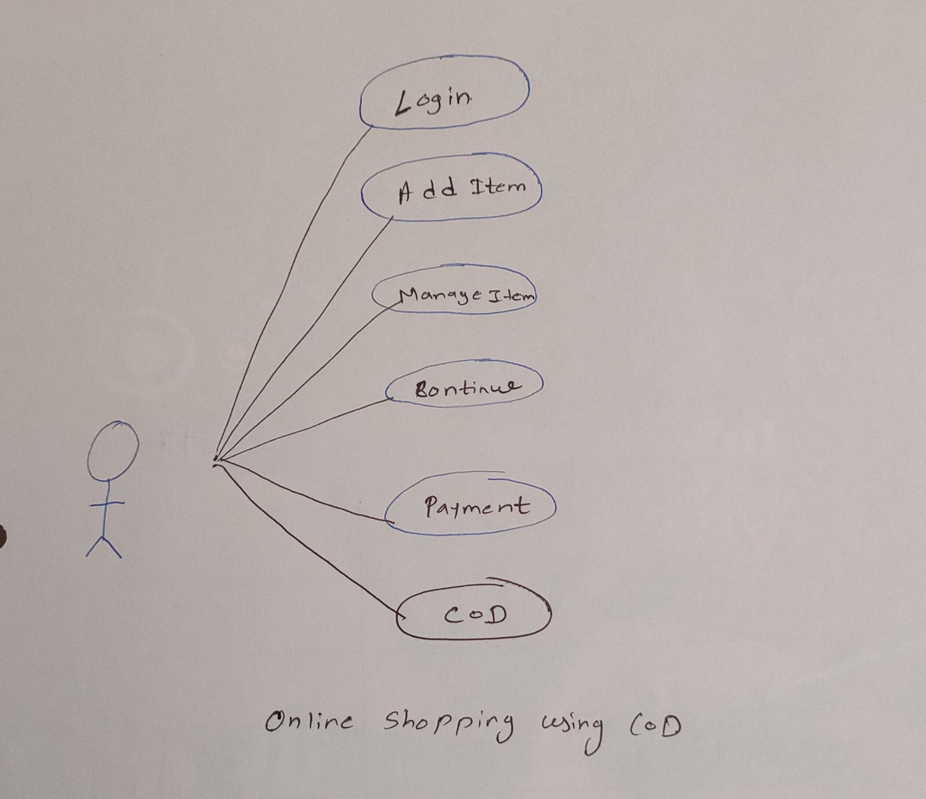

* **What is oop**
* **OOPS is Object oriented programming which identify object and assigned responsibility to the object.**
* **Write Basic Concepts of oops**
* **Classes and Objects**
* **Abstraction**
* **Encapsulation**
* **Inheritance**
* **Polymorphism**
* **What is object?**
* **An object is instance of an class and it is used To create memory for that class and to access the property of class accept private.This is the basic unit of object oriented programming.**
* **what is class?**
* **Class is a collection of data members ( variables) and Members function ( Process, method) with it’s behaviour. When you define a class, you define a blueprint for an object.**
* **what is encapsulation?**
* **Encapsulation is wrapping of data into single unit and private your data members and member functions. The internal state is usually not accessible by Other objects.**
* **What is inheritance?**
* **Inheritance means that one class inherits the characteristics of another class.**

**There are total five inheritance**

* **Single inheritance**
* **Multilevel inheritance**
* **Hierarchical inheritance**
* **Multiple inheritance**
* **Hydride inheritance.**
* **What is polymorphism?**
* **Polymorphism means having many forms.**
* **It allows different objects to respond to the same message indifferent**
* **ways, the response specific to the type of the object.**

**There are two methods.**

* **Method overloading**
* **Method overriding**
* **Method overloading: If a class has multiple methods having same name but different in parameters it is known as Method Overloading.**
* **Method overriding :Occurs when a subclass has the same method as the parent class.**